**Building an Interconnected Company Network Through Single-Area OSPF Routing**

Student Version



Huawei Technologies Co., Ltd.

|  |
| --- |
| **Copyright © Huawei Technologies Co., Ltd. 2020. All rights reserved.**  No part of this document may be reproduced or transmitted in any form or by any means without prior written consent of Huawei Technologies Co., Ltd.  **Trademarks and Permissions**  HW_POS_RBG_Vertical-150ppi.png and other Huawei trademarks are trademarks of Huawei Technologies Co., Ltd.  All other trademarks and trade names mentioned in this document are the property of their respective holders.  **Notice**  The purchased products, services and features are stipulated by the contract made between Huawei and the customer. All or part of the products, services and features described in this document may not be within the purchase scope or the usage scope. Unless otherwise specified in the contract, all statements, information, and recommendations in this document are provided "AS IS" without warranties, guarantees or representations of any kind, either express or implied.  The information in this document is subject to change without notice. Every effort has been made in the preparation of this document to ensure accuracy of the contents, but all statements, information, and recommendations in this document do not constitute a warranty of any kind, express or implied. |

|  |  |
| --- | --- |
| Huawei Technologies Co., Ltd. | |
| Address: | Huawei Industrial Base  Bantian, Longgang  Shenzhen 518129  People's Republic of China |
| Website: | <https://e.huawei.com/> |

**Huawei Certification System**

Huawei Certification follows the "platform + ecosystem" development strategy, which is a new collaborative architecture of ICT infrastructure based on "Cloud-Pipe-Terminal". Huawei has set up a complete certification system consisting of three categories: ICT infrastructure certification, platform and service certification, and ICT vertical certification. It is the only certification system that covers all ICT technical fields in the industry. Huawei offers three levels of certification: Huawei Certified ICT Associate (HCIA), Huawei Certified ICT Professional (HCIP), and Huawei Certified ICT Expert (HCIE). Huawei Certification covers all ICT fields and adapts to the industry trend of ICT convergence. With its leading talent development system and certification standards, it is committed to fostering new ICT talent in the digital era, and building a sound ICT talent ecosystem.

Huawei Certified ICT Associate-Datacom (HCIA-Datacom) is designed for Huawei's frontline engineers and anyone who want to understand Huawei's datacom products and technologies. The HCIA-Datacom certification covers routing and switching principles, basic WLAN principles, network security basics, network management and O&M basics, SDN and programmability and automation basics.

The Huawei certification system introduces the industry, fosters innovation, and imparts cutting-edge datacom knowledge.

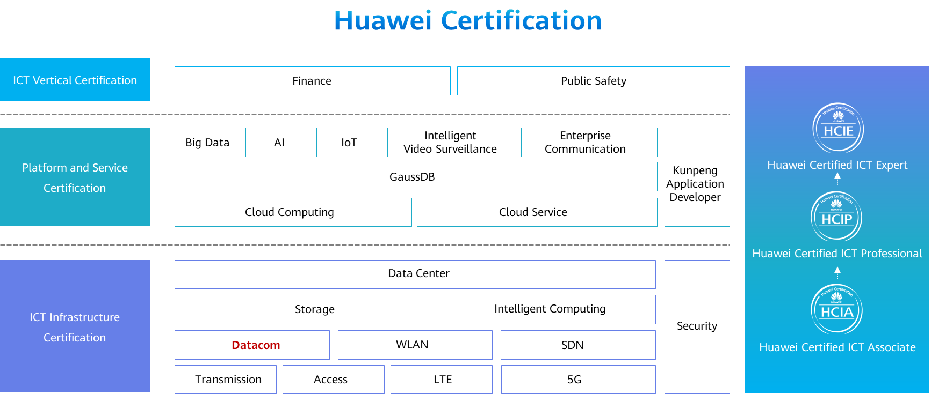

# Building an Interconnected Company Network Through Single-Area OSPF Routing

## Background

The company Jan16 has three offices: Beijing headquarters, Guangzhou branch, and Shanghai branch. The two branches are connected to the headquarters through routers. The company requires that single-area OSPF routing be configured so that the headquarters and two branches can communicate with each other. Figure 1-1 shows the network topology. The specific requirements are as follows:

1. R1, R2, and R3 are connected through VPNs.
2. R1, R2, and R3 are connected through single-area OSPF routing.
3. The IP addresses and interfaces of PCs and routers can be referred in following topology chapter.

## Objectives

Upon completion of this task, you will be able to:

Learn the basic commands of OSPF

Learn how to check the OSPF routing table

## Topology

Network topology

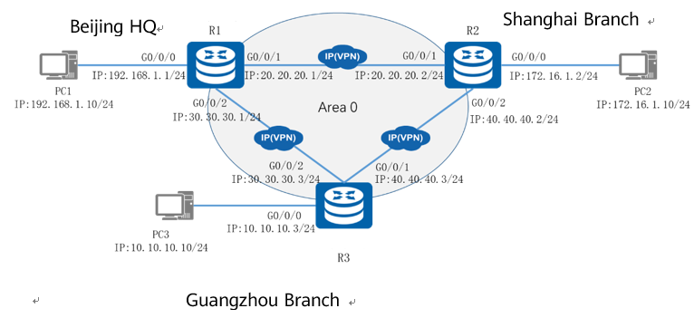

Beijing headquarters uses network segment 192.168.1.0, Shanghai branch uses network segment 172.16.1.0, and Guangzhou branch uses network segment 10.10.10.0. The network segment between R1 and R2 is 20.20.20.0, the network segment between R1 and R3 is 30.30.30.0, and the network segment between R2 and R3 is 40.40.40.0. All network segments use 24-bit subnet masks. Single-area OSPF routing needs to be configured on the routers so that all PCs of the company can communicate with each other.

The IP address planning and interface planning can be referred in the appendix.

## Implementation

### Roadmap

1. Configure interfaces on the routers.
2. Deploy a single-area OSPF network.
3. Configure an IP address and gateway address for each PC.

### Procedure

Configure interfaces on the routers.

#Configure R1.

#Configure R2.

#Configure R3.

Deploy a single-area OSPF network.

Create and run an OSPF process. Then, create an OSPF area, enter the OSPF area view, and specify the interface that runs OSPF and the area to which the interface belongs.

#Configure R1.

#Configure R2.

#Configure R3.

Configure IP addresses for PCs.

Configure the IP addresses of PCs referred by the appendix.

## Verification

Verify OSPF interface advertisement.

#OSPF interface information on R1

[R1]display ospf interface

OSPF Process 1 with Router ID 192.168.1.1

Interfaces

Area: 0.0.0.0 (MPLS TE not enabled)

IP Address Type State Cost Pri DR BDR

192.168.1.1 Broadcast DR 1 1 192.168.1.1 0.0.0.0

20.20.20.1 Broadcast DR 1 1 20.20.20.1 20.20.20.2

30.30.30.1 Broadcast DR 1 1 30.30.30.1 30.30.30.3

#OSPF interface information on R2

[R2]display ospf interface

OSPF Process 1 with Router ID 172.16.1.2

Interfaces

Area: 0.0.0.0 (MPLS TE not enabled)

IP Address Type State Cost Pri DR BDR

172.16.1.2 Broadcast DR 1 1 172.16.1.2 0.0.0.0

20.20.20.2 Broadcast BDR 1 1 20.20.20.1 20.20.20.2

40.40.40.2 Broadcast DR 1 1 40.40.40.2 40.40.40.3

#OSPF interface information on R3

[R3]display ospf interface

OSPF Process 1 with Router ID 10.10.10.3

Interfaces

Area: 0.0.0.0 (MPLS TE not enabled)

IP Address Type State Cost Pri DR BDR

10.10.10.3 Broadcast DR 1 1 10.10.10.3 0.0.0.0

40.40.40.3 Broadcast BDR 1 1 40.40.40.2 40.40.40.3

30.30.30.3 Broadcast BDR 1 1 30.30.30.1 30.30.30.3

In the command output, the **Type** field displays the default network type (**Broadcast)** of the Ethernet, and the **State** field indicates the role (DR or BDR) of an interface.

Check the OSPF neighbor status.

#OSPF neighbor status on R1

[R1]display ospf peer

OSPF Process 1 with Router ID 192.168.1.1

Neighbors

Area 0.0.0.0 interface 20.20.20.1(GigabitEthernet0/0/1)'s neighbors

Router ID: 172.16.1.2 Address: 20.20.20.2

State: Full Mode:Nbr is Slave Priority: 1

DR: 20.20.20.1 BDR: 20.20.20.2 MTU: 0

Dead timer due in 32 sec

Retrans timer interval: 5

Neighbor is up for 00:06:46

Authentication Sequence: [ 0 ]

Neighbors

Area 0.0.0.0 interface 30.30.30.1(GigabitEthernet0/0/2)'s neighbors

Router ID: 10.10.10.3 Address: 30.30.30.3

State: Full Mode:Nbr is Slave Priority: 1

DR: 30.30.30.1 BDR: 30.30.30.3 MTU: 0

Dead timer due in 36 sec

Retrans timer interval: 5

Neighbor is up for 00:06:27

Authentication Sequence: [ 0 ]

In the command output, the **Router ID** field indicates the router ID of a neighbor; the **Address** field indicates the IP address of the OSPF interface on the neighbor; the **State** field indicates the OSPF neighbor relationship status; the **Priority** field indicates the DR priority of the OSPF interface on the neighbor.

Check the OSPF routing table.

#OSPF routing table on R1

[R1]display ip routing-table protocol ospf

Route Flags: R - relay, D - download to fib

------------------------------------------------------------------------------

Public routing table : OSPF

Destinations : 3 Routes : 4

OSPF routing table status : <Active>

Destinations : 3 Routes : 4

Destination/Mask Proto Pre Cost Flags NextHop Interface

10.10.10.0/24 OSPF 10 2 D 30.30.30.3 GigabitEthernet0/0/2

40.40.40.0/24 OSPF 10 2 D 20.20.20.2 GigabitEthernet0/0/1

OSPF 10 2 D 30.30.30.3 GigabitEthernet0/0/2

172.16.1.0/24 OSPF 10 2 D 20.20.20.2 GigabitEthernet0/0/1

OSPF routing table status : <Inactive>

Destinations : 0 Routes : 0

In the preceding OSPF routing table, the **Destination/Mask** field indicates the destination address and mask of a route; the **Proto** field indicates the routing protocol of this route, which is OSPF in this example; the **Pre** field indicates the preference of this route; the **Cost** field indicates the cost of this route; the **NextHop** field indicates the next-hop address of the route; the **Interface** field indicates the outbound interface of this route.

Test connectivity between PCs.

Run the ping command to test connectivity between PCs.

#Ping PC2 from PC1.

[C:\~]$>ping 172.16.1.10

Ping 172.16.1.10: 32 data bytes, Press Ctrl\_C to break

From 172.16.1.10: bytes=32 seq=1 ttl=126 time=16 ms

From 172.16.1.10: bytes=32 seq=2 ttl=126 time=31 ms

From 172.16.1.10: bytes=32 seq=3 ttl=126 time=31 ms

From 172.16.1.10: bytes=32 seq=4 ttl=126 time=32 ms

From 172.16.1.10: bytes=32 seq=5 ttl=126 time=31 ms

--- 172.16.1.10 ping statistics ---

5 packet(s) transmitted

5 packet(s) received

0.00% packet loss

round-trip min/avg/max = 16/28/32 ms

#Ping PC3 from PC1.

[C:\~]$>ping 10.10.10.10

Ping 10.10.10.10: 32 data bytes, Press Ctrl\_C to break

From 10.10.10.10: bytes=32 seq=1 ttl=126 time=16 ms

From 10.10.10.10: bytes=32 seq=2 ttl=126 time=31 ms

From 10.10.10.10: bytes=32 seq=3 ttl=126 time=16 ms

From 10.10.10.10: bytes=32 seq=4 ttl=126 time=31 ms

From 10.10.10.10: bytes=32 seq=5 ttl=126 time=31 ms

--- 10.10.10.10 ping statistics ---

5 packet(s) transmitted

5 packet(s) received

0.00% packet loss

round-trip min/avg/max = 16/25/31 ms

The preceding information shows that PCs can communicate with each other.

----**End**

### Appendix

IP address planning

| **Device** | **Interface** | **IP Address** |
| --- | --- | --- |
| R1 | G0/0/0 | 192.168.1.1/24 |
| R1 | G0/0/1 | 20.20.20.1/24 |
| R1 | G0/0/2 | 30.30.30.1/24 |
| R2 | G0/0/0 | 172.16.1.2/24 |
| R2 | G0/0/1 | 20.20.20.2/24 |
| R2 | G0/0/2 | 40.40.40.2/24 |
| R3 | G0/0/0 | 10.10.10.3/24 |
| R3 | G0/0/1 | 40.40.40.3/24 |
| R3 | G0/0/2 | 30.30.30.3/24 |
| PC1 | Eth0/0/1 | 192.168.1.10/24 |
| PC2 | Eth0/0/1 | 172.16.1.10/24 |
| PC3 | Eth0/0/1 | 10.10.10.10/24 |

Interface planning

| **Local Device** | **Local Interface** | **Peer Device** | **Peer Interface** |
| --- | --- | --- | --- |
| R1 | G0/0/0 | PC1 | Eth0/0/1 |
| R1 | G0/0/1 | R2 | G0/0/1 |
| R1 | G0/0/2 | R3 | G0/0/2 |
| R2 | G0/0/0 | PC2 | Eth0/0/1 |
| R2 | G0/0/1 | R1 | G0/0/1 |
| R2 | G0/0/2 | R3 | G0/0/1 |
| R3 | G0/0/0 | PC3 | Eth0/0/1 |
| R3 | G0/0/1 | R2 | G0/0/2 |
| R3 | G0/0/2 | R1 | G0/0/2 |
| PC1 | Eth0/0/1 | R1 | G0/0/0 |
| PC2 | Eth0/0/1 | R2 | G0/0/0 |
| PC3 | Eth0/0/1 | R3 | G0/0/0 |